# BudgetPak Getting Started Guide for Users



­Overview

This Getting Started Guide contains instructions for how to complete your Budget.

BudgetPak supports several levels of users. In your budget there may be information you cannot view and operations you cannot perform because the scope and role assigned to you do not allow it. The permissions you are granted depend upon your BudgetPak “role,” which the Administrator has assigned to you based on your budget responsibilities within your department. Each user’s role is associated with his or her user login profile.

About Your Budget

In BudgetPak your department(s) (“unit”) and their general ledger accounts (“accounts”) have already been set up for you; however, you will be accessing each account and entering its annual expense or revenue budget amount.

The prior year actual and budget have been loaded into BudgetPak as well for historical reference during budgeting and for reporting. The instructions below describe how to print reports, so that you can use these numbers as a guide to creating this year’s budget.

Logging In to BudgetPak

To open BudgetPak:

1. Go to BudgetPak: (<https://daemen.mybudgetpak.com/BudgetPakWeb/Default.aspx>) The BudgetPak Log In box displays.
2. In the first box, enter the username that was assigned to you.
3. In the second box, enter the password that was assigned to you. You will then be prompted to create a new password.
4. Click the **Log In** button.
   1. Note that IE has a clipboard access prompt that you will want to disable. Click the ‘browser setting tips’ on the login page.

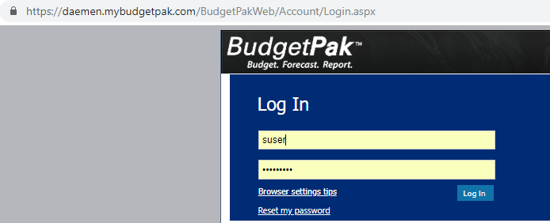

Creating the Budget

From the Main Menu:

1. Select the **Create New** to create a new budget; the Create a New Budget page displays.

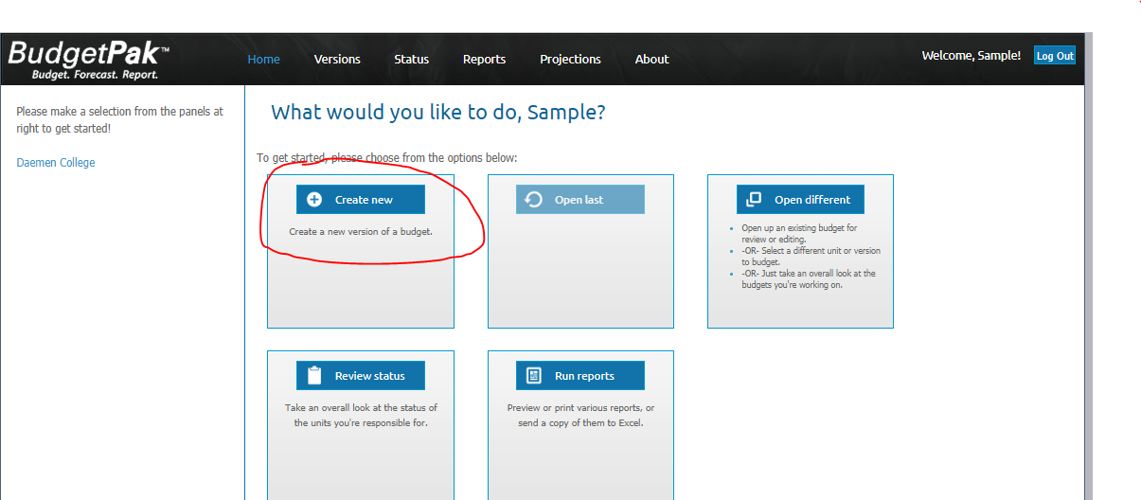

1. In the **Step 1** panel of the box that displays, select the department or unit you want to budget (use the drop-down menu or click the ‘Select’ button to view the list of options), and click **Next**. If you have more than one unit, they will appear under step 1 of this page (Follow the steps and select the default for step 2).
2. In the **Step 2** panel, click **Next** to accept the suggested name “2019-20 Final Budget.”
   * + If you have multiple versions of your budget, you can choose the one to start.
3. In **Step 3** of the box that displays, accept the default – select **No, start my budget from scratch**, and click **Start**.

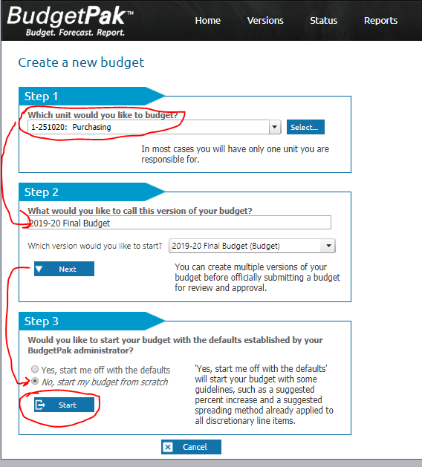

Using the Budget Navigation Page to enter Annual Budget amounts

1. In the Start Budgeting box select **I’ll Choose Where to Begin**. The Budget Navigation Page displays. This is your unique set of accounts that your unit needs to budget.

NOTE: In BudgetPak each column in the Budget Navigation Page is called a “**stack**;” and each box is called a “**section**.”

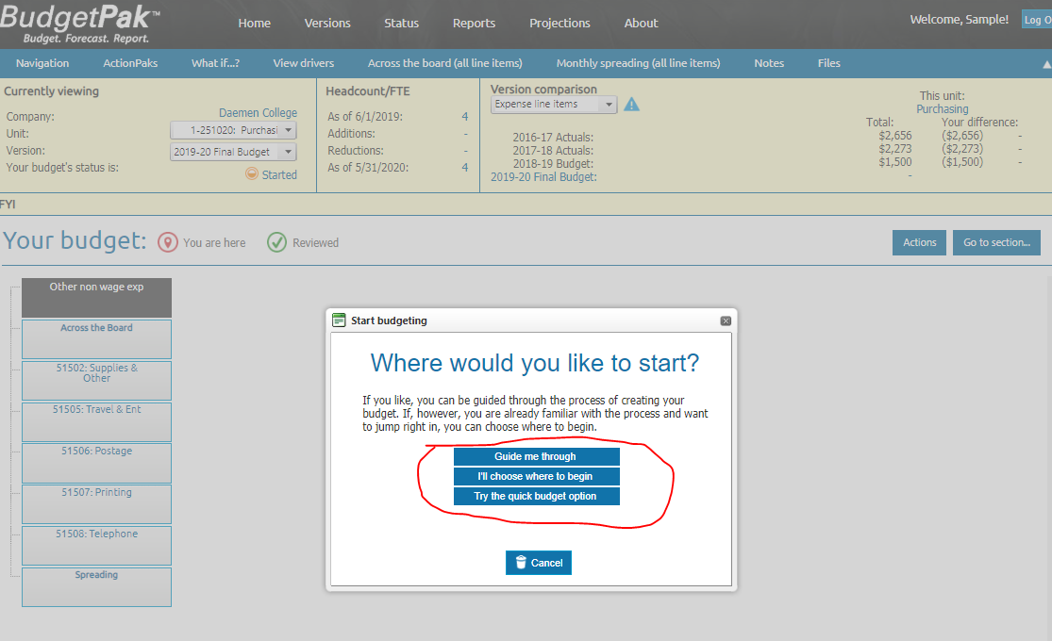

This will appear if you select "Guide Me" from Step 4. Hit select or cancel to move on.

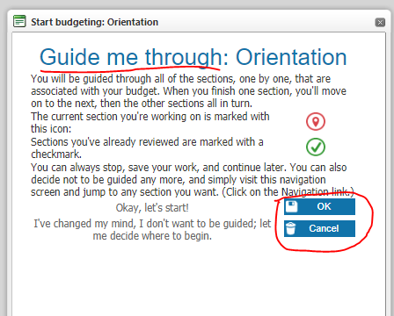

1. In the Budget Navigation Page click **any section (account)** you want to budget. The Account page displays.

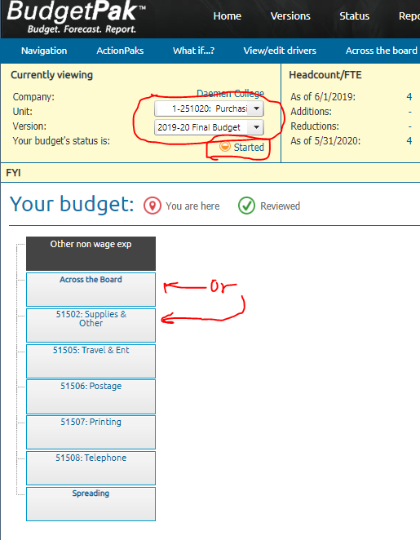

In **Step 1** of the Annual total for [account name] page, you can use one of the following methods to enter an annual amount. You must choose one budget method for each line item.

* By annual amount (most used) – enter an annual amount
* By percent increase - The basis for the % increase is listed here, e.g. FY2018 Budget. Enter a percent increase/decrease and the annual amount is automatically calculated.
* By per head - Your currently budgeted headcount is listed here, as of the final date in your budget fiscal year. Enter your annual amount per head and the annual amount is automatically calculated.
* By line item detail (most used) - You can build up your annual budget by entering line item detail. The detail is included on some P&L reports. Add as many rows as you want and/or Import Details to import all line items from a previous version. Enter a description for the detail line, and an annual amount for it. Click the Recalcbutton to display the total.
* By driver x rate (advanced users) - You can build up your annual budget by multiplying a quantity times a rate. You may select the quantity and/or the rate from a list of pre-defined drivers, or you may enter either of them manually.
* By rows and columns (advanced users)- This budget method provides you with a spreadsheet-like utility with which to create the line item’s annual (or monthly) amount.



1. In **Step 2**, click Edit to enter any relevant comments about the account and its annual budget amount in the text box provided or click Import Notes from Prior Budget to review and edit notes from previous versions.
   * + Some notes may be mandatory.
     + Some accounts may have an administrator-defined category list, from which you can select multiple categories to tag to that account.

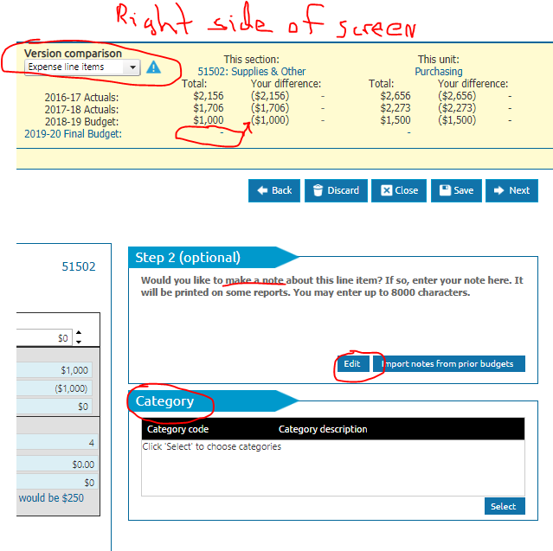

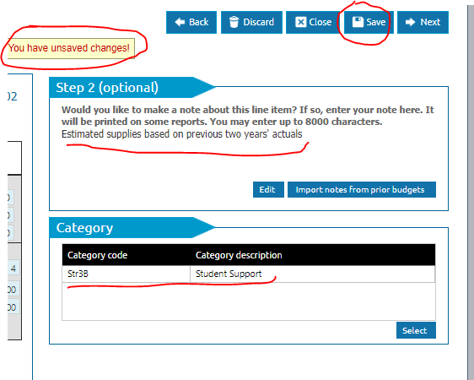

1. Click **Save** (located just below the Version Comparison box) to save your changes.

Review the variance amounts in the Version Comparison box to see how you are doing against targets.

1. Click **Close** to close the account page and return to the Budget Navigation Page; or, click **Next** to save the current value and move to the next section/account in the stack.

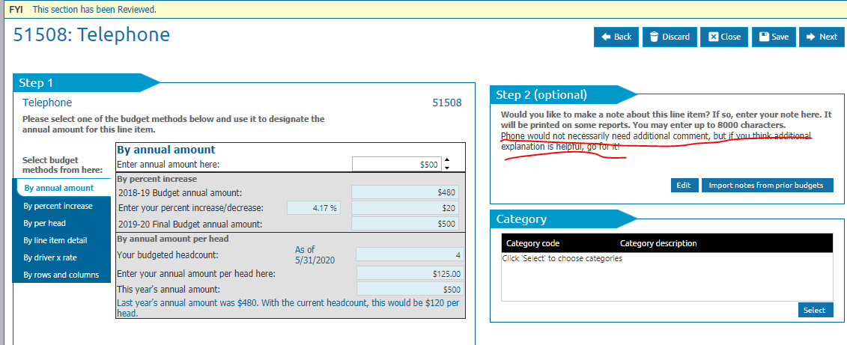

NOTE: In the Budget Navigation Page, you will notice that a green check mark within a circle has been placed in the upper left of the account section to indicate that you have entered a budget amount for the account.

1. Repeat Steps 7 through 11 until all of your accounts have been populated with an annual budget amount. NOTE: You may have some accounts that have pre-designated values that you cannot change, such as benefits or insurance. You will still need to review these accounts in order to get the green check mark and complete your budget.
2. If you signed out, when you come back, log in and select “open last” to easily return to where you left off.

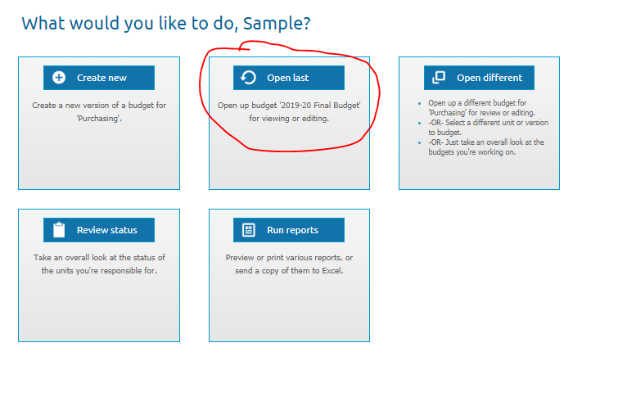

Spreading the Annual Amount over a Number of Months

At this point, the annual budget for each account needs to be spread over 12 months (if you want to change the amounts in each month or spread the annual amount over less than 12 months, see the section “Manually Overriding Monthly Amounts,” below).

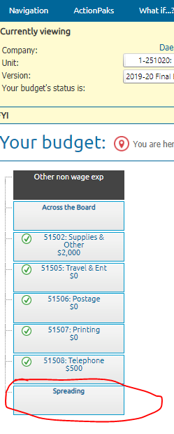

1. In the Budget Navigation Page, at the bottom of every stack is a section called “Monthly Spreading.” Scroll down the list of accounts until you reach the end of the stack. Click on **Monthly Spreading**.
2. In **Step 1** of the monthly spreading page that displays, accept the default, **Spread all line items the same way**.
3. In **Step 2**, accept the default, **Based on “FY2017” Actual monthly amounts**. Selecting this option will distribute each monthly amount according to the seasonality reflected in the noted version.
4. Click **Save** to save the monthly spreading.
5. Click **Close** to return to the Budget Navigation Page.

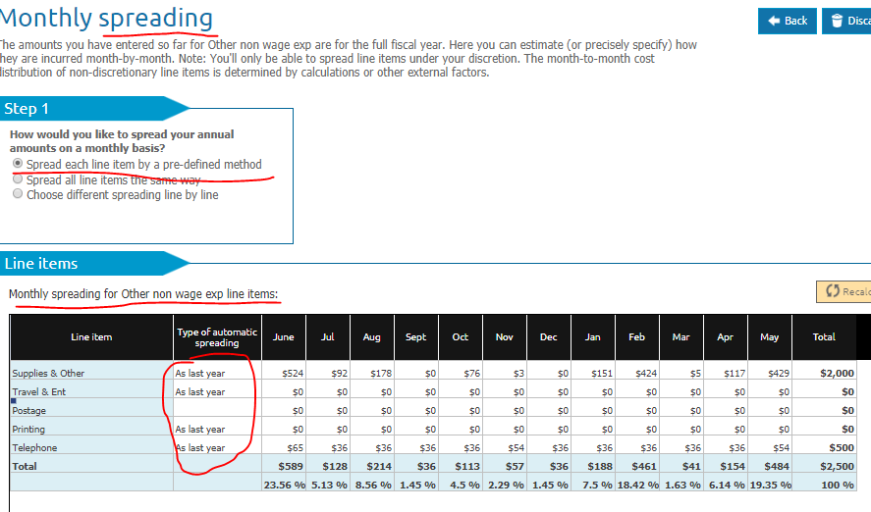

## Manually Overriding Monthly Amounts

If you need to manually override any of the monthly amounts,

1. Scroll through the list of the accounts to locate the account you want to manually change.
2. Locate the month for which you want to override the amount and click in the box containing the monthly amount you wish to change.
3. Change the displayed amount to the correct amount. Click the **Recalc** button. You will note that all other monthly amounts automatically adjust to compensate for the new amount.

Any monthly amount that has been manually overridden will appear in yellow highlight.

1. Click **Save** to save any overrides.
2. Click **Close** to return to the Budget Navigation Page.

## Alternative Spreading Methods

You can change the spreading method by account by clicking on, in **Step 1, Choose different spreading line by line.** In the Line Items section of the screen, double-click on white box in the **Type of Automatic Spreading** column to switch spreading methods.

1. Evenly - Spread evenly throughout the year; essentially a divide by 12
2. By Days - Spread based on the number of days in the month
3. None - Do not do automated spreading. All monthly values must be entered manually; the total recalculates to be the sum of all values.
4. Line Item Detail Spreading – If you used Budget Method - Line Item Details for an account, you can optionally click on **Expand** to individually spread each amount.

Unit (Department) Notes and Files

1. Admin files - These are files that are uploaded by the administrator and get assigned to a version. These files will then show up here for all budgets that fall under that version.
   1. In the Blue Navigation bar, click **Files**. You can click on a filename to download any files listed on the Admin tab.
2. User files - These are files that are uploaded by users who have write access to the budget to support budget assumptions and requests
   1. In the Blue Navigation bar, click **Files.** On the User tab, click **Upload** to upload any file. Click **Save**. Optionally, click **Mappings** to assign that file to specific accounts.
3. Notes - These are unit-wide notes entered by users who have write access to the budget or entered by approval managers during a revoke activity.
   1. In the Blue Navigation bar, click **Notes.** Click **Add** to enter a new note, **Edit** to edit an existing note, or **View** to view a note that an approval manager or Administrator has assigned to your unit (department).

ActionPaks

ActionPaks are an optional feature that you can use to budget for unit-specific initiatives, projects, programs or campaigns. Any amount entered into an ActionPak is additive to the amount already entered for that line item in your general budget.

1. Click **ActionPaks** in the blue navigation menu at the top of your screen.
2. Click the **Add ActionPak** button and enter a name for this ActionPak or use **Import Action Paks** to import accounts and values from a prior version. Enter a code for this ActionPak. Click **Save** and then **Close** to return to the Budget Navigation Page.
3. A new stack called ActionPaks will appear as the rightmost stack in your Budget Navigation Page. The section underneath will contain the name of your ActionPak.
4. Click on the new section and budget as you would any other account.
   1. The line item usage box will show you the amount already budgeted for that line item in your general budget.
   2. The summary box will show you the individual line item amounts and total for the ActionPak.
5. Continue to add additional ActionPaks as needed.

Note: Any line item which you used in an ActionPak will now appear in a Line Item Usage box within the general budget. When you click on a section in your Budget Navigation Page that relates to an ActionPak(s), you will see the general budget value, the ActionPak value and the total value for that line item.

* All P&L reports will display the total value for each line item.
* Run an ActionPak report to see the individual ActionPaks with their associated line items, amounts and notes.
  + In Advanced Reporting, Step 1, choose ActionPaks only within the Group Accounts By: box.

Reviewing Headcount & Salaries

If you have Headcount (employees) in your unit (department) or if you are authorized to review Headcount & Salaries, you will see a stack called **Headcount & Salaries** in your Navigation page.

1. Click the top section **Headcount Review** to make sure that you have the correct list of employees for your unit with the proper salaries. If not, please contact your BudgetPak Administrator.
   1. In **Steps 2, 3 and 4** enter thedates for those employees who are leaving permanently or temporarily. Enter notes in the Employee Notes field to add commentary.
   2. You can display additional columns or hide current columns by clicking the **Show/hide columns…** button.
   3. Click **Save** to save your entries or **Next** to save and move to the next section in theHeadcount & Salaries Stack.
2. Plan for any new employees in the next section, **New Hires.**
   1. In the **Step 1** panel, Select **Yes** or **No** to**Will you be hiring anybody?**
   2. If **Yes,** In **Step 2**, click **Add a New Hire** button
   3. Enter all appropriate information for the New Hire on the various tabs
   4. Click **Save** when you are finished to return to the **Add a New Hire** page.
   5. Continue to follow steps 2b – 3d for all new hires.
   6. Click **Next** to move to the next section in theHeadcount & Salaries Stack
3. Plan for any **Salary Increases** in the next sections.
   1. In **Step 1** **How would you like to budget raises?,** select the italicized default –By percent, Allocate from a pool, or Fixed amount by employee
   2. In **Step 2** **How would you like to handle raises**?, select the italicized default – Give everyone the same raise, Give ‘everyone except’ the same raise, or Provide raises by individual
   3. In **Step 3** **How would you like to set the date for the raise**? select the italicized default – Use HR-defined date for everyone
   4. Click **Save** to save your entries or **Next** to save and move to the next section in theHeadcount & Salaries Stack.
   5. Continue to follow steps 3a – 3d for all Salary Increases sections.
4. Review **Monthly Spreading** screen. No changes are necessary. Click **Save.**

Across the Board

The across-the-board pages make it fast and easy to change a number of line items all at once.

1. Click Across the Board change at the top of the stack.
2. **Step 1** asks you to which method you want to use to make across the board changes: By percent increase/decrease, a total line item increase/decrease, or a fixed amount per employee.
3. In **Step 2**, designate which discretionary line items to which it will be applied.
   1. Use the Apply Standard Increase column to include or exclude individual line items from the across-the-board change designated in Step 2.
   2. By excluding individual line items, you can change any values (% increase, $ increase, $per head, annual amount) independently.
4. Click **Recalc** to show the final values and then **Save**.

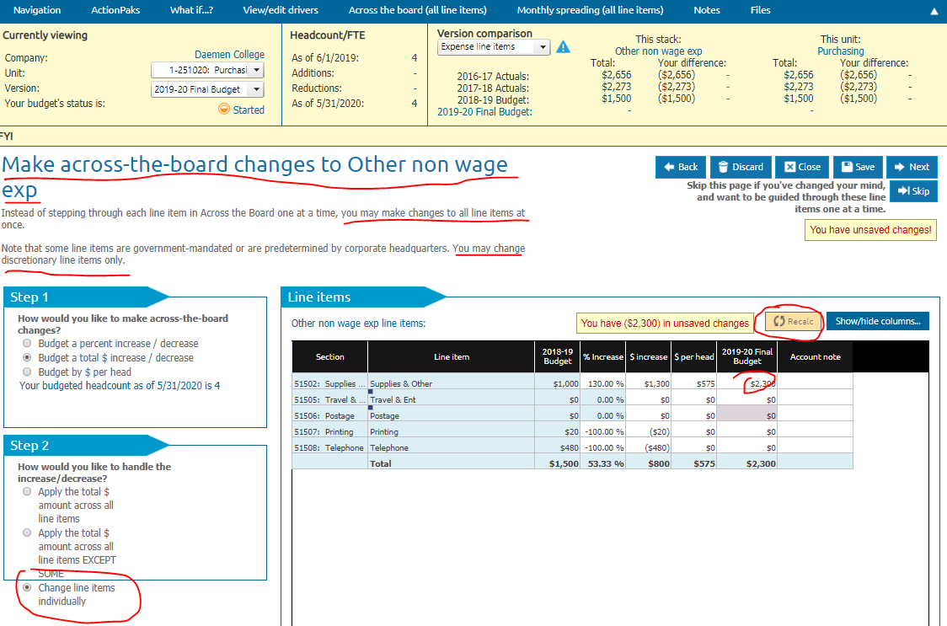

Bonus comment: If you select "Make across the board changes", this is what it looks like. Note that the "Show/Hide" columns is used to add account notes. This is helpful if you have a lot of small balance accounts you want to update.

Printing the Budget

Once you have performed the monthly spreading, you can print a report of your current annual budget compared to last year’s budget or actuals, or you can print a report showing the monthly amount for each account in your budget.

1. On the toolbar at the top of the page, click **Reports**. The Reports screen displays.
2. To display your budget data, click the **View** button in the first box, *My Budget Summary.*
   * + Your report will open in a new page.
     + Use your browser to print your report, or alternatively choose to send your report to Excel or PDF.

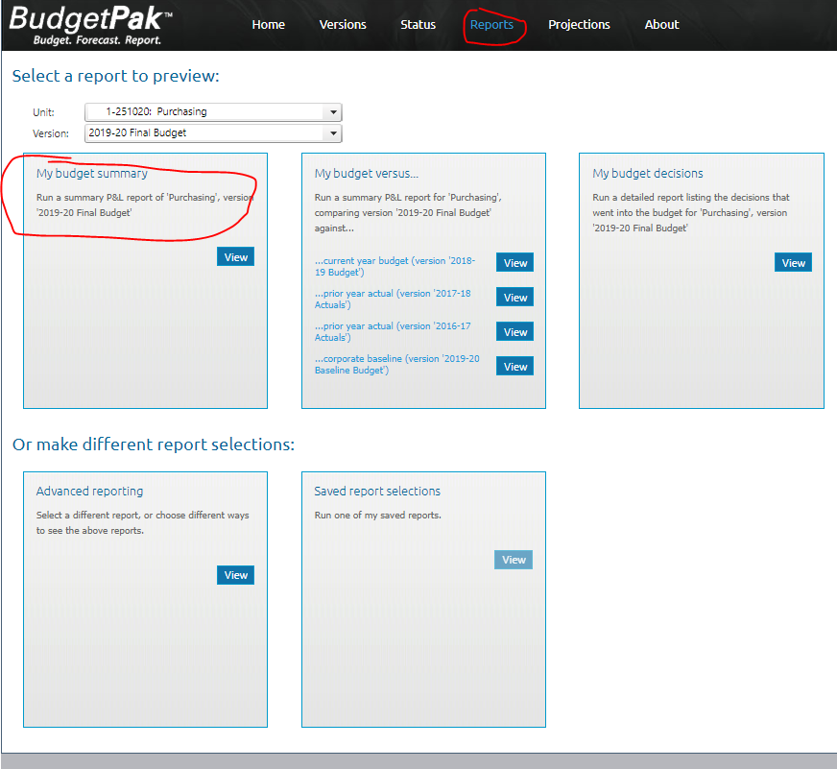

Bonus comment: Note that the "Reports" tab allows for easy printing or saving of reports to PDF, Printer, or Excel. This is entirely at the user’s discretion. You cannot hurt anything by playing around in here!

1. For a comparison against last year’s budget, in the second box, *My budget versus…*, click **View** next to the **Prior Year Budget** button.
2. To print the detail of all decisions - headcount, assets, ActionPaks and line item details - in the third box, *My Budget Decisions,* click **View**.
3. To print a report showing the monthly amount for each account in your budget, click **View** in the **Advanced Reporting** box.
   * + In the **Step 1: Select a Report** panel, select P&L Reports.
     + From the **Select the date range** panel, select **Monthly**.
     + Click the **Select** button to the right, and at top of the Select the months to be printed box, click **Print all months**, and click **OK**.
     + In the **Step 2: Select the version(s)** panel, in the Report on which version? panel, select the version (e.g. FY2019 Budget Draft 1 or FY2019 Budget Final) you are currently working on.
     + In the **Step 3: Select units** panel, click **Change unit selections**, and use the buttons on the top to display the units. Check the box(es) of the unit(s) you wish to report on.
     + In the **Step 6: View report** panel, Click the **View** **the report** button.
       - Your report will open in a new page.
       - Use your browser to print your report, or alternatively choose to send your report to Excel or PDF.

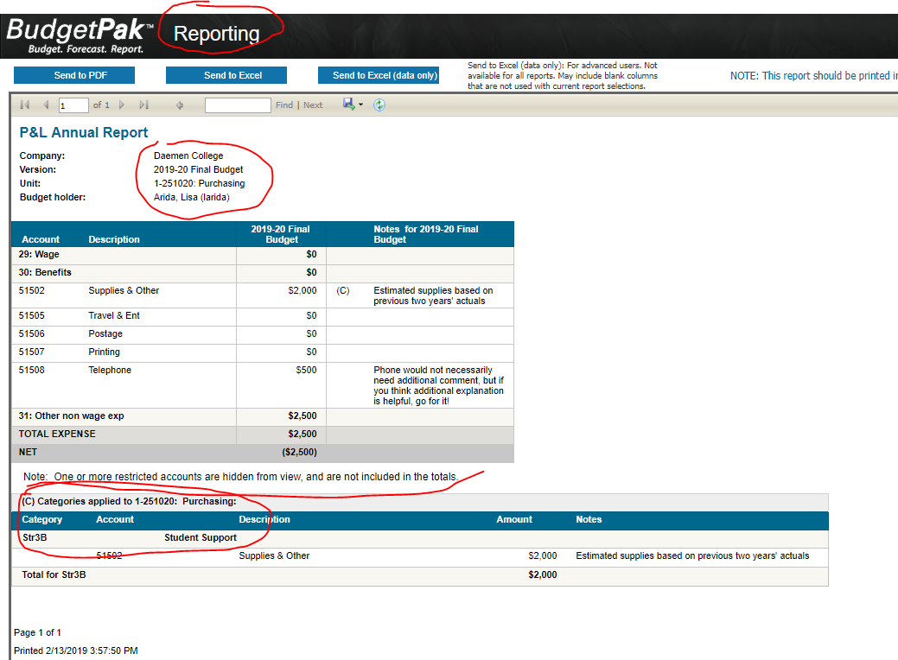

*Bonus comment: Sample report of "My Budget Summary" Note that, in this case, some accounts are restricted and cannot be viewed. Note also the “notes” at the right of each budget line and the category (strategic plan linkage) at the bottom.*

Completing and Signing-off on your Budget

The proper way to complete a draft budget is to review each account in the department individually and then save the budget. Green check marks must appear on every section in the Budget Navigation Page in order to submit your budget for approval.

1. On the toolbar at the top of the page, click **Versions**. The Version Selection page displays.
2. In the **Step 1** panel, select the department you want to submit for approval.
3. In the Copy a Budget screen, Step 1, use the drop down box to select **FY2019 Budget Final**. In Step 2, leavethe default name. Click **OK**.
4. You should be back in the Version Selection page and you will see a sign-off button in the green highlighted row (or look for Sign off button in the column called ‘Signed off’).
5. Click the **sign-off** button;
6. Click **Yes** to confirm you want to sign-off on the budget. The budget is now signed-off and ready to be approved by Approval Managers. Once a budget is signed-off, you can no longer make any changes to it, unless your Approval Manager re-opens that budget for you.
7. Your budget is now complete and you may log out of BudgetPak.

NOTE: For each department for which you are responsible for submitting a budget, all of the steps in all of the sections above must be completed.

Approving Budgets

Approval Managers have the responsibility of approving the budget for each of their units (departments), as well as the roll-up unit to which they are assigned.

1. On the toolbar at the top of the page, click **Status**. The unit Status page displays, showing the budget status for all departments for which you are responsible.
2. In the upper left Select Version panel of the Status page, verify that you are viewing the correct budget. If not, find and click on it in the dropdown menu then click, ‘Update the view with these selections’.
   * + In the Select Status Information panel, make sure that status box is checked.
3. Click on the row containing the first unit that contains the “signed-off” icon, which is a green checkmark inside a green circle. (When you select the unit, the row will be highlighted in blue.)
4. Click the **Approve** button (located above list of units). Note that the icon changes to a green thumbs-up and the status changes to ‘Approved.’ This indicates that the budget for that unit is now approved by you.
5. Repeat Steps 3 and 4 until all of the units for which you are responsible have been approved.
6. At the roll-up unit level, which contains your name as the budgetholder, click the **Sign-off** button.
   * + You may have to select the **Rollup** button first to consolidate all the budgets.
7. Once you have Signed-off, your budgets can be reviewed and rolled up by the next level of Approval Managers.

On-Demand Templates

On-Demand Templates, an optional feature intended for advanced users, is accessible from the Action menu. This feature allows you to readily use Excel in conjunction with BudgetPak. The templates are considered ‘on-demand’ because they don’t have to be created in advance by your Finance department. You can create them whenever you want, for any version and any unit, fill them in (partially or in full), and then bring the contents (again, in part or in full) back into BudgetPak. On-Demand Templates produces an Excel workbook that has all of the accounts and current account values for the current version and unit. It is an exact replica of what you get on the ‘Spreading-all line items’ page, formulas and all. The workbook is protected, with the discretionary line items unlocked.

1. From the **Action** button at the top right of the Budget Navigation Page select Create on-demand template. Designate a name for the template file.
2. Open the file in Excel. All line items and months are displayed in the template, exactly as they are in the ‘Spreading all line items at once’ page. The template includes some hidden ‘marker’ rows, used by BudgetPak when you import the template. Do not modify or delete them, or you might not be able to import your template. Non-discretionary line items are displayed in light gray, and are locked for editing by default.
3. Copy your model into an empty worksheet.
   * + - Create a cell reference in the On-Demand Template on the appropriate rows to reference the monthly values in your model. **Save** the file.
4. Select Import from on-demand template from the Action menu.
5. Click **Select** to select the Excel file that contains your template. Click **Open.**
6. When the template is first previewed, line items that differ from the existing values in the version and unit, and are eligible for import, are automatically flagged ‘Will be imported’. If you decide that you do NOT want to import a line item at this time, you may de-select it in the ‘Will be imported’ column. You may select all eligible line items, or none, by clicking on **Select all rows for import** or **Deselect all rows.**
7. Click **Import Now** when you are ready to import. The rows with ‘Will be imported’ checked will be imported.
8. Review the imported values in the appropriate section(s) and in Monthly Spreading.
   * + - Each line item imported from a template will have its automatic spreading method set to ‘None’, as indicated. (The reason is that monthly line item data are being imported, not annual data; and presumably you want to import these monthly values into BudgetPak as-is.)

The figure below describes the components of the Budget Navigation Page.

Informational Boxes

Version Comparison Box

Menu Functions

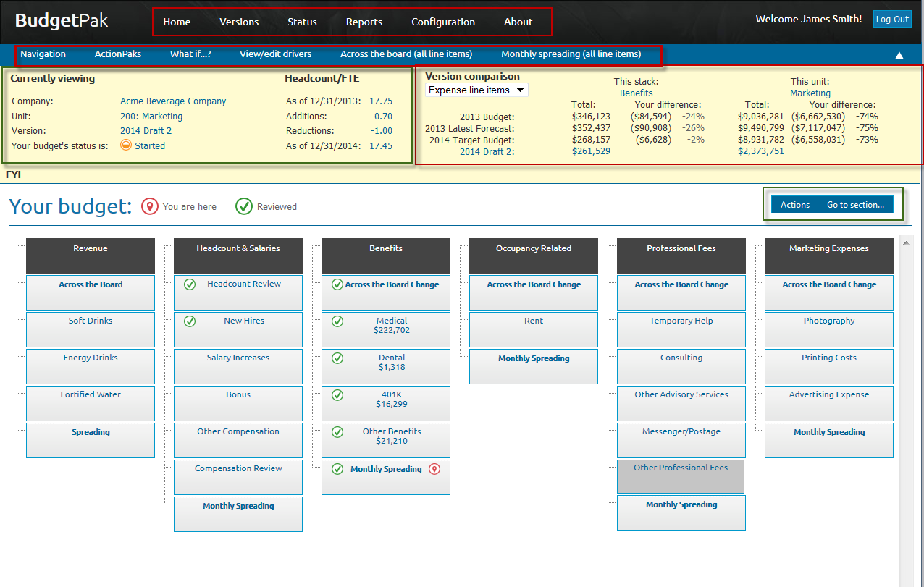

Unit Functions