Create Your Own Snack Checklist
Directions: Circle whether you believe you had a happy or sad experience.
Happy Sad
Helpfulness:  I helped create the snack.   | 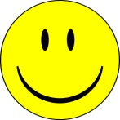 | 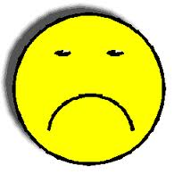
Attitude:

I had a positive attitude.

Directions:
I followed directions.
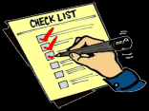

Total:

