My Healthy Meal Checklist
Directions: Check whether you believe you had a happy or sad experience
I wrote my name on the paper and the title of my project.   |  | 

I have all six of the food groups in my meal (dairy, protein, sweets/oils, fruits and vegetables).

My project is easy to read, there are no spelling mistakes, and the food is neatly put on the plate.


All of the food on my plate is labeled with the food’s correct name.
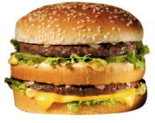

hamburger
Total:

