**Classroom Rules**



1. Use inside voices[](http://www.google.com/imgres?imgurl=http://www.glamourmouse.com/products/images/shh!%20smiley%20face.jpeg&imgrefurl=http://www.glamourmouse.com/products/ebook.htm&usg=__DgSzdC0101dwmqjLqlZtR296Jwo=&h=1500&w=1500&sz=209&hl=en&start=31&zoom=1&tbnid=18BItznfW5T8PM:&tbnh=174&tbnw=174&ei=c3hQTe-3EcGitgfc_Ki3AQ&prev=/images?q=shh&um=1&hl=en&biw=1659&bih=865&tbs=isch:1&um=1&itbs=1&iact=hc&vpx=1113&vpy=358&dur=666&hovh=225&hovw=225&tx=106&ty=140&oei=anhQTcTtF8OB8gaH5JifDg&esq=2&page=2&ndsp=33&ved=1t:429,r:6,s:31)

[](http://www.google.com/imgres?imgurl=http://www.glamourmouse.com/products/images/shh!%20smiley%20face.jpeg&imgrefurl=http://www.glamourmouse.com/products/ebook.htm&usg=__DgSzdC0101dwmqjLqlZtR296Jwo=&h=1500&w=1500&sz=209&hl=en&start=31&zoom=1&tbnid=18BItznfW5T8PM:&tbnh=174&tbnw=174&ei=c3hQTe-3EcGitgfc_Ki3AQ&prev=/images?q=shh&um=1&hl=en&biw=1659&bih=865&tbs=isch:1&um=1&itbs=1&iact=hc&vpx=1113&vpy=358&dur=666&hovh=225&hovw=225&tx=106&ty=140&oei=anhQTcTtF8OB8gaH5JifDg&esq=2&page=2&ndsp=33&ved=1t:429,r:6,s:31)

[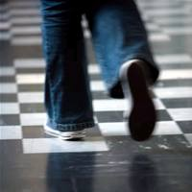](http://www.google.com/imgres?imgurl=http://www.enterpriseinnovation.net/system/files/egovasia/walking-feet.jpg&imgrefurl=http://www.enterpriseinnovation.net/tag/workforce+mobility&usg=__PNXdaDmj_c3rps8wvDxvDyJ3AEU=&h=250&w=250&sz=43&hl=en&start=28&zoom=1&tbnid=RmC0G9NbxLPkkM:&tbnh=170&tbnw=164&ei=ynhQTdHyNMSftwed07C1AQ&prev=/images?q=walking+feet&um=1&hl=en&biw=1659&bih=865&tbs=isch:1&um=1&itbs=1&iact=rc&dur=254&oei=u3hQTbXHOIep8Aamx6yaDg&esq=2&page=2&ndsp=30&ved=1t:429,r:22,s:28&tx=80&ty=109)

2.) Use walking feet

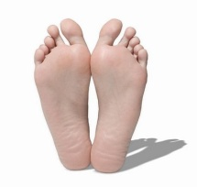

1. Keep your hands and feet to yourself

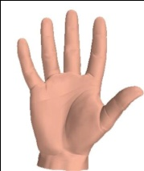[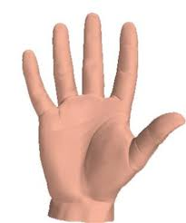](http://www.google.com/imgres?imgurl=http://www.chaaps.com/wp-content/uploads/2009/12/hands.jpg&imgrefurl=http://www.chaaps.com/5-fingers-of-your-blog-hand-google-facebook-twitter-digg-reddit.html&usg=__NtU8mO235_cr3pItRd72eWElTOg=&h=373&w=312&sz=21&hl=en&start=0&zoom=1&tbnid=TfUoDrY0GnrItM:&tbnh=169&tbnw=141&ei=Y3lQTcWYK4G78gbUy5CsDg&prev=/images?q=hand&um=1&hl=en&biw=1659&bih=865&tbs=isch:1&um=1&itbs=1&iact=hc&vpx=134&vpy=103&dur=309&hovh=246&hovw=205&tx=94&ty=159&oei=Y3lQTcWYK4G78gbUy5CsDg&esq=1&page=1&ndsp=32&ved=1t:429,r:0,s:0)

[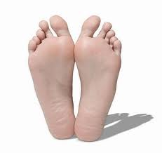](http://www.google.com/imgres?imgurl=http://4.bp.blogspot.com/_iKcZ3qcCmyo/SFvkMwTH8PI/AAAAAAAAIFY/vmYwxpWSVYw/s400/feet-761353.jpg&imgrefurl=http://deathby1000papercuts.blogspot.com/2008/06/vancouver-bc-foot-mystery-sixth-foot.html&usg=__Eq6d7Xx6K-7Zcd3w5NOYYsCGDNA=&h=377&w=400&sz=13&hl=en&start=0&zoom=1&tbnid=cyp6OgYLE2kdcM:&tbnh=151&tbnw=150&ei=BHpQTfiaCYH-8Ab1yPyuDg&prev=/images?q=feet&um=1&hl=en&biw=1659&bih=865&tbs=isch:1&um=1&itbs=1&iact=hc&vpx=612&vpy=225&dur=146&hovh=218&hovw=231&tx=132&ty=110&oei=BHpQTfiaCYH-8Ab1yPyuDg&esq=1&page=1&ndsp=35&ved=1t:429,r:3,s:0)

4.) Follow directions given by adults



5.) Raise your hand to share[](http://www.google.com/imgres?imgurl=http://www.650shortsale.com/wp-content/uploads/2010/08/grief-hands.jpg&imgrefurl=http://www.650shortsale.com/2010/08/raise-your-hand-for-help/&usg=__K265oahSLqtaWHDS2lJfW3miK9A=&h=430&w=346&sz=30&hl=en&start=0&zoom=1&tbnid=SQWEPyM1kB5_EM:&tbnh=176&tbnw=142&ei=PXtQTdPKH4K78gbc04ywDg&prev=/images?q=raise+your+hand&hl=en&biw=1676&bih=865&gbv=2&tbs=isch:1&itbs=1&iact=hc&vpx=580&vpy=283&dur=1056&hovh=250&hovw=201&tx=74&ty=174&oei=PXtQTdPKH4K78gbc04ywDg&esq=1&page=1&ndsp=31&ved=1t:429,r:10,s:0)