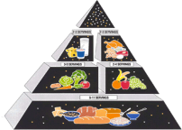**Tops Supermarket Field Trip**

Dear Parents,

We are going on a field trip! On Friday, March 4th, the students will go to Top’s Supermarket to participate in a cooking school. We will be learning about the food groups and a healthy lifestyle. To conclude this fun unit, we are going to take a tour of different sections of the grocery store, do a scavenger hunt of ingredients, and then cook our own lunch. We will leave school at 9:30 A.M. and return to school at 12:30 P.M. Students who eat breakfast at school will still be able to do so. Students will not need to bring or buy lunch.

The cost of this field trip is $4 per student. Please return the permission slip along with the $4 by Friday, February 18th.

Thank You!

Miss Schaeffer

- - - - - - - - - - - - - - - - - - - - - - - - - - - - - - - - - - - - - - - - - - - - - - - - - - - - - - - - - - - - - - -

My child _______________________ has permission to attend the Tops Supermarket Field Trip on Friday, March 4th.

**I have enclosed the $4:** ________

**Parent Signature:** _____________________________

**Emergency Contact and Phone Number:** ___________________________________________________