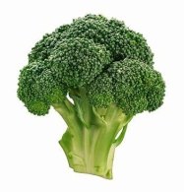
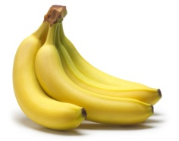

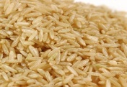
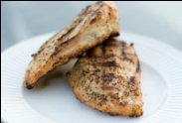
My Healthy Meal Rubric

Attribute | Healthy- 4 | Almost There- 3 | Slightly Unhealthy- 2 | Unhealthy- 1
Name and Title  Maximum of 4 | Student wrote name on the project as well as a title that incorporates the name of the meal. | Student wrote their name as well as the title but is missing the name of the meal. | Student is missing name or title incorporating the name of the meal. | Student is missing both their name as well as the title of the project incorporating the meal.
Accuracy  Maximum of 8 | Student has all six of the different food groups incorporated (grains, dairy, proteins, fruits, vegetables, and sweets/oils). | Student has four or five food groups incorporated. | Student has two or three food groups incorporated. | Student has only one food group incorporated.
Neatness  Maximum of 4 | The project is easy to read, there are no spelling errors, and the different items of food are neatly placed on the plate | The project is either a little difficult to read, has a spelling error, or two items of food are on top of each other. | The project has two of the following: a little difficult to read, has a spelling error or two, or the items of food are on top of each other. | The project has several negative qualities such as: difficult to read, has multiple spelling errors, and the food is on top of each other.
Labels  Maximum of 4 | All of the food on the plate is labeled with the correct name. | One item is not labeled or labeled incorrectly. | Two items are labeled incorrectly or not labeled on the plate. | Three or more items are labeled incorrectly or are not labeled.

Comments: Score: ____/20

