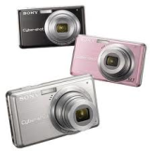**Photography Parental Consent Form**

Dear Parents,

I am writing this letter in hopes that you will give me permission to photograph your child. Photographs will only be taken during learning activities and field trips. These photographs will be used for my professional student teaching portfolio as well as for classroom arts and crafts. Throughout my time in Ms. Kiel’s class, I have planned many fun and exciting activities for the students to participate in and I would love to capture these memories.

Sincerely,

Miss Schaeffer

- - - - - - - - - - - - - - - - - - - - - - - - - - - - - - - - - - - - - - - - - - - - - - - - - - - - - - - - - - - - - - -

_____ I give parental consent to allow my child to be photographed for educational purposes only.

Parent Signature and Date:

__________________________________________

_____ I do not give parental consent for my child to be photographed for educational purposes.

Parent Signature and Date:

__________________________________________