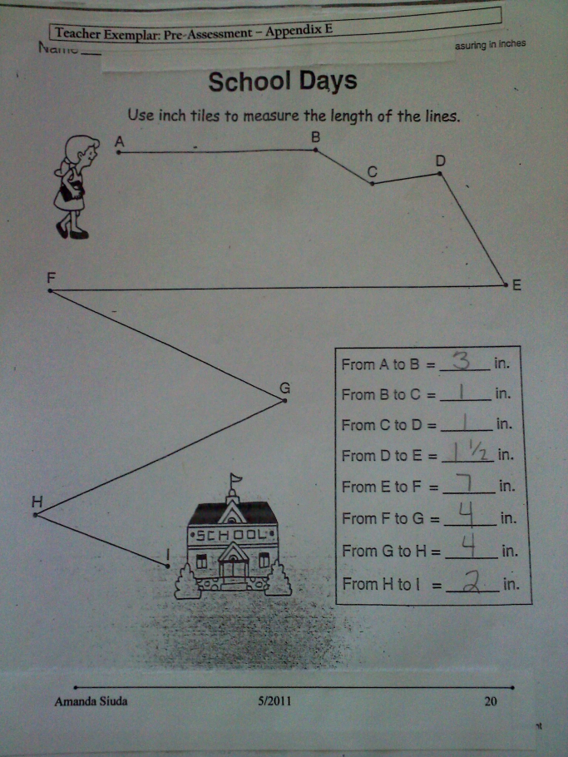
The students were given this activity as part of their morning work routine. This is the teacher exemplar of what the students were expected to produce by measuring each line with color tiles.

