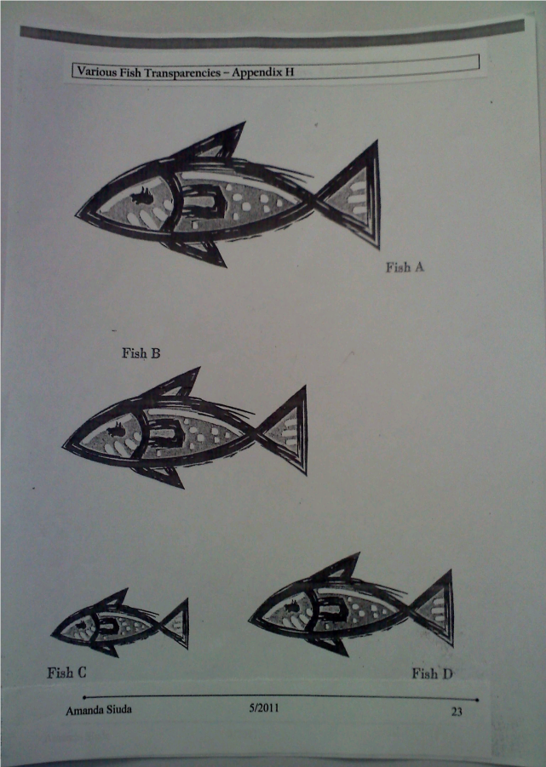

Each of the following fish were measured by using color tiles as a non-standard unit of measurement.